UNIVERSITY OF WAH (UOW)

DEPARTMENT OF COMPUTER SCIENCE



BSCS 3RD B

REG #: UW-24-CS-BS-088

SUBMITTED BY: SAADI SAFDAR

SUBMITTED TO: Ms. MUNNIBA KHAN

COURSE TITLE: DATA STRUCTURES

COURSE CODE: CS – 201 L

LAB REPORT # 9

Assigned tasks in lab.
1.
#include <iostream>
using namespace std;
const int MAX = 5; // Maximum size of stack
int stack[MAX]; // Stack array
int top = -1; // Top pointer (stack is empty)
void push(int value) {
if (top == MAX - 1)

cout << "Stack Overflow" << endl;
else {
top++;
stack[top] = value;
cout << value << " pushed into stack" << endl;
}
}
void pop() {
if (top == -1)
cout << "Stack Underflow" << endl;
else {
cout << stack[top] << " popped from stack" << endl;
top--;
}
}
bool isEmpty() {
return (top == -1);
}
int getTop() {
if (top == -1)
return -1;
else
return stack[top];
}
int count() {
return top + 1;
}
int main() {
push(10);
push(20);
push(30);
cout << "Top element: " << getTop() << endl;
cout << "Total elements: " << count() << endl;

pop();
pop();
if (isEmpty())
cout << "Stack is empty" << endl;
else
cout << "Stack is not empty" << endl;
return 0;
}
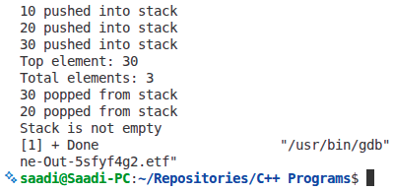

2.
#include <iostream>
#include <stack>
using namespace std;
int main() {
stack<int> s;

s.push(10);
s.push(20);
s.push(30);

cout << "Top element: " << s.top() << endl;
cout << "Total elements: " << s.size() << endl;

s.pop();
cout << "Top element after one pop: " << s.top() << endl;

if (s.empty())
cout << "Stack is empty" << endl;
else
cout << "Stack is not empty" << endl;

return 0;
}
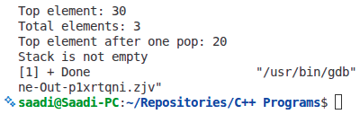

3.
#include <iostream>
using namespace std;

struct Node {
int data;
Node* next;
};

Node* top = NULL;

void push(int value)
{
Node* newNode = new Node();
newNode->data = value;
newNode->next = top;
top = newNode;
cout << value << " pushed into stack" << endl;
}

void pop() {
if (top == NULL)
cout << "Stack Underflow" << endl;
else
{
Node* temp = top;
cout << temp->data << " popped from stack" << endl;
top = top->next;
delete temp;
}
}

void displayTop() {
if (top == NULL)
cout << "Stack is empty" << endl;
else
cout << "Top element: " << top->data << endl;
}

int main() {
push(100);
push(200);
push(300);
displayTop();
pop();
pop();
displayTop();
return 0;
}

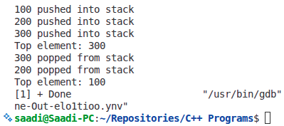

Lab Tasks
Instructions:
• Solve the following problems using C++.
• Think carefully about how the data should be stored and managed.
• You may implement any necessary functions to complete the tasks.
Q1: Browser History Simulation
A browser keeps track of pages visited. The user can go “Back” to the previous page.
• Simulate storing the last 5 pages visited.
• Go back 2 pages.
• Display the current page.
• Display the total number of pages remaining in history.

#include <iostream>
#include <stack>
using namespace std;
int main() {
stack<string> browserHistory;
browserHistory.push("page1.com");
browserHistory.push("page2.com");
browserHistory.push("page3.com");
browserHistory.push("page4.com");
browserHistory.push("page5.com");

if (!browserHistory.empty()) browserHistory.pop();
if (!browserHistory.empty()) browserHistory.pop();

if (!browserHistory.empty())
cout << "Current page: " << browserHistory.top() << endl;
else
cout << "No pages in history" << endl;

cout << "Total pages in history: " << browserHistory.size() << endl;

return 0;
}
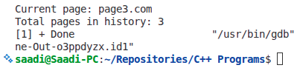

Q2: Stack Using Array
• Implement a stack of integers using an array.
• Perform 3 push operations, 2 pop operations.
• Display the top element and total elements in the stack.

( SAME AS PROGRAM 1 ASSIGNED IN LAB )

Q3 (Scenario – Linked List Stack)
Scenario: Undo-Redo System in a Drawing App
A drawing application keeps track of user actions (like drawing lines, shapes, or erasing) for
Undo functionality.
• Each action is stored as an integer ID.
• The last action performed can be undone first (LIFO).
Tasks:
1. Implement a stack using a linked list to store user actions.
2. Perform the following sequence:
o Push 5 actions (IDs: 101, 102, 103, 104, 105).
o Undo 3 actions (pop operations).
o Display the most recent action still active.
o Check if the stack is empty after the undo operations.
3. Add an extra check: If the stack becomes empty and the user tries to undo another action,
display a “No actions to undo” message.

#include <iostream>
using namespace std;
struct Node {
int actionID;
Node* next;
};
Node* top = NULL;
void push(int actionID) {
Node* newNode = new Node();
newNode->actionID = actionID;
newNode->next = top;
top = newNode;
cout << "Action " << actionID << " performed and added to stack" << endl;
}
void pop() {
if (top == NULL) {
cout << "No actions to undo" << endl;
} else {
Node* temp = top;
cout << "Action " << temp->actionID << " undone" << endl;
top = top->next;
delete temp;
}
}
void displayTop() {
if (top == NULL) {
cout << "No active actions" << endl;
} else {
cout << "Most recent active action ID: " << top->actionID << endl;
}
}
bool isEmpty() {
return (top == NULL);
}
int main() {
push(101);
push(102);
push(103);
push(104);
push(105);
pop();
pop();
pop();
displayTop();
if (isEmpty()) {
cout << "No actions remaining in stack" << endl;
} else {
cout << "There are still actions in the stack" << endl;
}
pop();
pop();
pop(); // This will display "No actions to undo"
return 0;
}
